**Handling float/short image**

**Objective**

A program to calculate NDVI (floating point) image (nikko-si.tif)

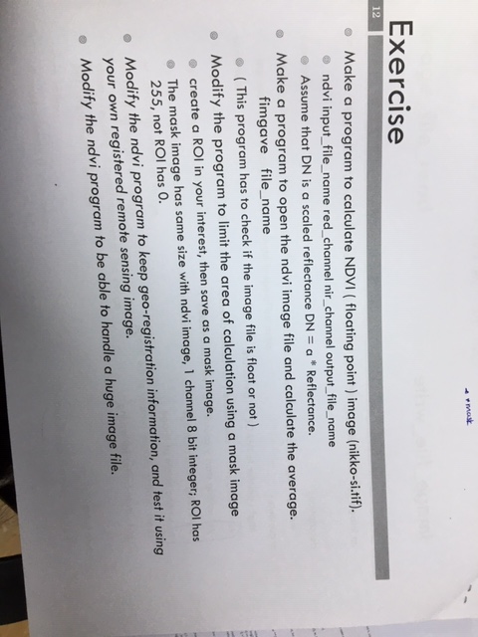

**Code Descriptions**

//declare directives//

#include<stdio.h>

#include<math.h>

#include "image.h"

#include "imgio.h"

void usage(void)

{

fprintf(stderr,"usage: ndvi inputfile redBandIndex NIRBandIndex outputFile\n");

}

//DECLARE FUNCTIONS//

//function declaration for NDVI calculation.(float **pixO) to access to each pixel of output image, a pointer of float data type prepared//

int ndvi_cal(u_char **vr, u_char **nir, float **pixO, int w, int h);

//function declaration for NDVI mask calculation//

int ndvi_mask_cal(u_char **red, u_char **nir, float **pixO, u_char **mask, int w, int h);

//main part of function//

//define variables; argc, argv, *imgI, *imgO, w,h,nchan, Vr_Index, NIR_Index, *imageFnameI, *imageFnameO,**vr, **nir //

void main(int argc, char **argv[]){

IMAGE *imgI,*imgO; // Image input, Image output

IMAGE_FILE *imgfI, *imgfO; // ImageFile input, ImageFile Output

int w, h, nchan,vr_index, nir_index; // width, height, VR index, NIR index

char *imageFnameI, *imageFnameO; // Image Filename Input, Image Filename Output

u_char **vr, **nir;

if (argc !=5){ // check amount of input arguments

usage();

exit(1);

}

// assign arguments value to variable

/*receive image file, number of NIR band, number of Red band and output image file name from user*/

imageFnameI = argv[1];

vr_index = atoi(argv[2]);

nir_index = atoi(argv[3]);

imageFnameO = argv[4];

// image file open input image  
if ((imgfI = image_file_open(imageFnameI, IMAGE_RDONLY, IMAGE_BUFFERED)) == NULL){ //if error in image file name, read only or buffered ; exit the program//

printf("Image_file_open_error\n");

exit(2);

}

//obtain spec of the image without data memory//

imgI = imgfI->image;

w = imgI->w;

h = imgI->h;

vr = imgI->data[vr_index - 1]; // get Red Image

nir = imgI->data[nir_index - 1]; // get NIR Image

imgO = image_alloc(w, h, IMAGE_FLOAT,1); //image allocation with image_float and band number 1 is going to use

if (imgO == NULL){

fprintf(stderr, "contrast: output image file allocate error %d %d %d\n", w, h, nchan);

exit(4);

}

//Calling NDVI calculation function

ndvi_cal(vr, nir, imgO->data[0], w, h);

//create a new file output//

imgfO = image_file_create(imageFnameO, IMAGE_TRUNC, 0, imgO);

if (imgfO == NULL){

fprintf(stderr, "contrast: output image file create error %s\n", imageFnameO);

exit(5);

}

image_file_close(imgfO); // close output file

image_destroy(imgO); // destroy image

image_file_close(imgfI); // close input file

return 0;

}

/*Function to calculate NDVI image pixel by pixel*/

int ndvi_cal(u_char **vr, u_char **nir, float **pixO, int w, int h){

int i, j;

for (i = 0; i < h; i++){

for (j = 0; j < w; j++){

pixO[i][j] = (float)(((double)nir[i][j] - (double)vr[i][j]) / ((double)nir[i][j] + (double)vr[i][j]));

}

}

return 0;

}

**Output**

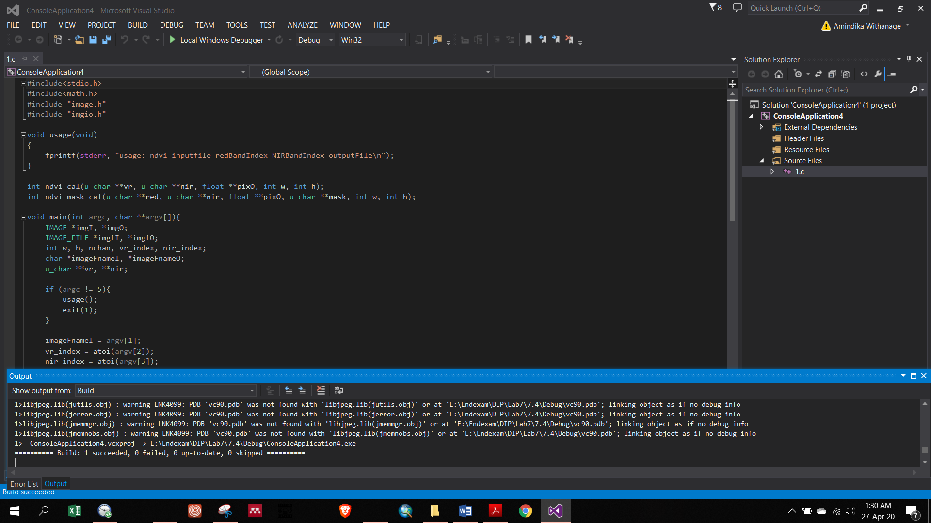

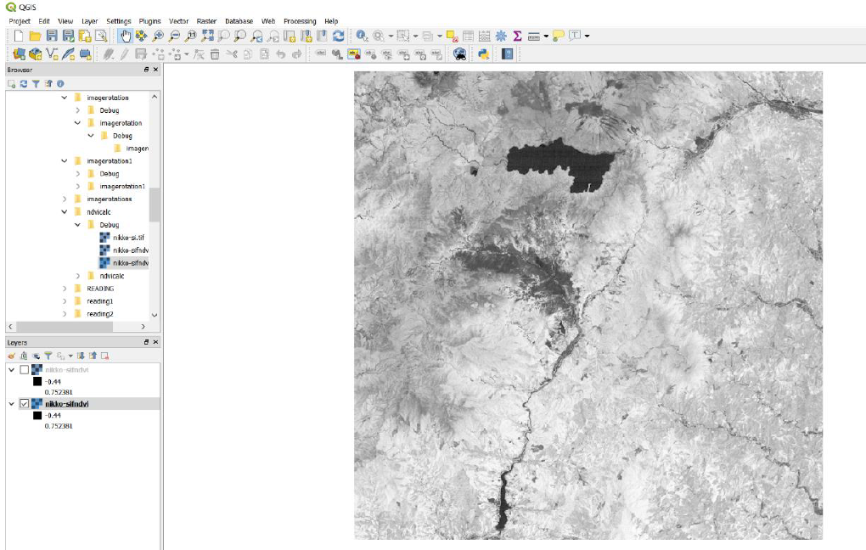

**Figure: NDVI image**